Title (Bold Face, Pt 14, Calibri)
Petrov I.L.¹, Kuznetsov S.M.², Please underline the presenting Author (pt 12)
1 – Boreskov Institute of Catalysis, Novosibirsk, Russia
2 – Affiliation of Author 2..... (pt 12, italic)
E-mail of the presenting Author (pt 12, italic)

Authors of all contributions are invited to submit one or two pages, A4, abstracts in English. Tables, artworks and references will be accepted within this limit. The text should be typed 1.25 line spaced (2 cm all around margin). Please use Calibri 12 pt. References should be cited in the order of occurrence in the text as a numbers in square brackets [1].
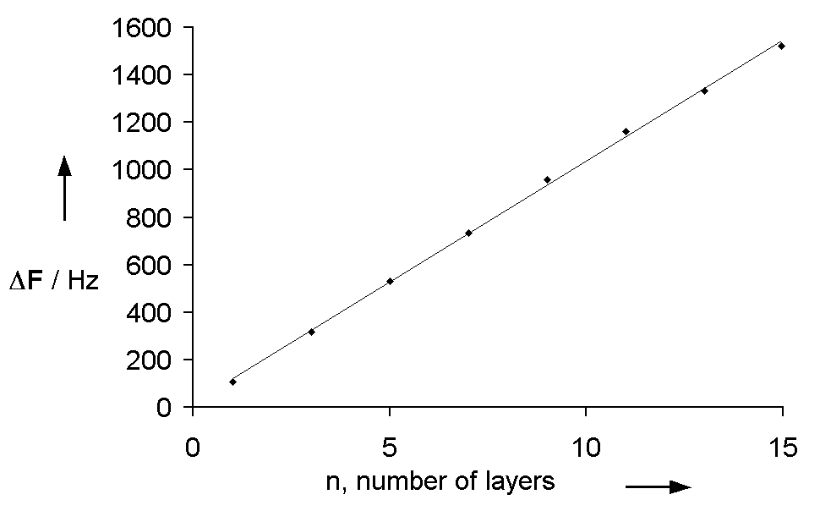

Fig. 1. Figure caption (12 pt, Calibri)
Authors are requested to send their abstracts as a Microsoft Word file via the conference website. Abstracts will be peer reviewed following a standard procedure.

Acknowledgement. This work was supported by the Russian Science Foundation, grant 14-13-12345.

References:

[1] C. Sarantes, M. Stoikides, J. Catal. 93 (1985) 417.

[2] Reference 2 (pt 11)…

